St. David’s episcopal church - rector search
90 South Main Street, Cranbury, NJ
(609)655-4731

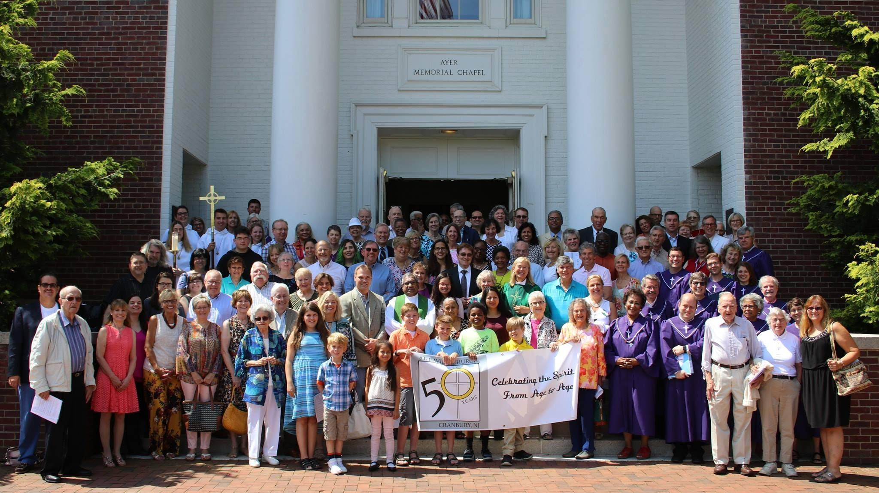

Who we are
St. David’s Episcopal church, located in Cranbury, NJ within Middlesex county seeks a Rector for its large, diverse and welcoming parish. Our worship community seeks a leader with whom to partner as we continue to foster our tradition of strong lay leadership and egalitarian culture.
There are many forms of ministry here at St. David’s that demonstrate that God is immanent in our community. We have a strong and dedicated congregation that supports a Sunday School and family services program, Adult Choir led by our Emmy-winning composer and conductor, Dr. Brian Katona, Journey to Adulthood (J2A) program, Adult Forums, Bible Studies, Book Clubs, extensive community outreach, fundraisers, and congregational team building activities. The services and culture here are a blend of traditional Anglican services with the influence of contemporary attitudes and open arms to all those who wish to worship.

Our worship services and culture are a blend of formal services from the Book of Common prayer conducted in a modern church and by a vibrant, warm congregation. We would like to partner with someone who can help us foster growth and development in our fun-loving and down-to-earth congregation. Established in 1969, our current facility opened in 1982, and has a free standing altar without a communion rail; individual padded chairs with kneeling benches and ample space to host our three services per week; a family service once per quarter; special services for church celebrations; an adult choir that sings traditional classical and contemporary music; and a children’s Sunday school choir that sings once per quarter. We host weekly Sunday Coffee Hour post-10 am services and support a strong portfolio of community activities, religious study groups, a nursery and a children’s program, a garden program, and a congregational picnic.
Our Oasis Welcoming pledge reads,
“As a welcoming congregation, we at St. David’s church are committed to inviting, supporting and welcoming all people as full members of our church, family and worship life; particularly our brothers and sisters who have experienced exclusion because of their sexual orientation or identity and are seeking a safe and affirming spiritual home.”
Our church vision is that God is calling St. David’s Church to welcome people to Christ’s community to:
- share with us in His eternal priesthood;
- extend Christ’s love by embracing diversity and promoting tolerance within the community and the world;
- meet the physical and spiritual needs of all God’s people using the resources, confidence and opportunities He has given us;
- develop and sustain nurturing and committed leaders and clergy;
- provide the facilities and resources necessary to engage and educate our youth to create a nurturing environment for all; and
- exemplify the mission of St. David’s church through faith and commitment.

St. David’s Episcopal church of Cranbury, NJ is a part of the NJ Diocese. The church sits on six acres of land within Cranbury, a quaint, historic community that is 300 years old and is 15 mins from Princeton, NJ. The area is suburban, diverse and engaged. The town is ~1 hour outside of both New York City and Philadelphia, within Middlesex County, and has a large catchment area within one of the most populous and wealthiest areas of the State. St. David’s has a long-standing history with Trinity Church and the Princeton Theological Seminary. The parish is conveniently located within an hour of both the mountains and the beach and is surrounded by a myriad of excellent public and private schools, colleges and universities.

What we seek…
Our dynamic Rector, a previous congregation member, retired in May of 2019. Therefore, we seek a confident and energetic Rector to partner with us to grow into a new future together that values family, Anglican traditions and pragmatic engagement and biblical interpretation and story-telling. We seek a new leader who is naturally welcoming, has a wise soul to mentor and coach, and an embracing spirit that makes our diverse congregation feel that everyone is welcomed and engaged.

We seek a Rector who will:
- strengthen family life ministries that attract parents, children and youth;
- deliver excellent sermons that are temporally relevant;
- possess strong parish administration skills, including development of a governance process that involves church members in decision-making and inspires and guides lay people in leadership roles;
- maintain and strengthen the Christian Education/Formation that we now have that relates to all ages/stages of life;
- continue worship experiences that deepen the congregation’s relationship with God and one another;
- assist in the further development of ministries of service to the wider community;
- support the growth of our pastoral ministries that serve those in times of need.

Our future Rector should engage us in scholarly intellectual discussion and debate while guiding the congregation through our biblical journey in a manner that is inclusive to people of all levels of knowledge.

While the Rector at St. David’s does not need to personally lead all of the many internal activities and community-based outreach activities, our Rector should have an eye for what the various members of our group have to offer. Engaging everyone in a way that suits their personal situation is what made us the strong parish we have become. We say that everyone has a way to contribute to the St. David’s family, whether it’s with their treasure (contributions), their talents or their time.

